TITTLE: HUFFMAN ALGORITHM GUIDE

Written by: M. Muzammil Tanvir, Muhammad Nouman

This manual will teach and explain everything you need to know about compression algorithms, specifically Huffman encoding. After reading this manual, you will be able to understand and implement the compression algorithm effectively.

Working:

Libraries used and basic class structure:

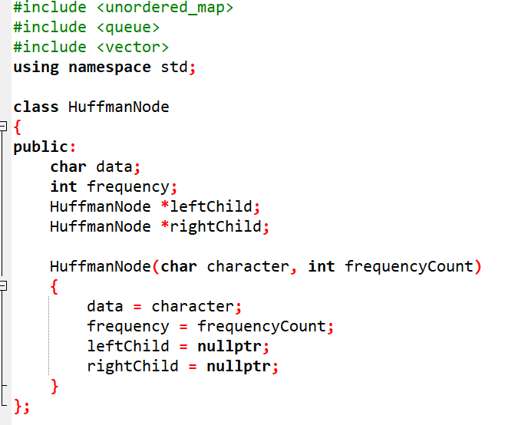

Step 01:

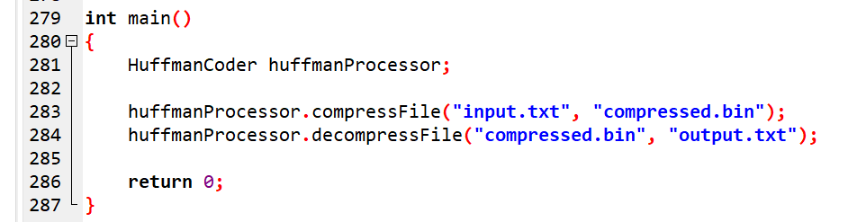

Firstly, we created an object for HuffmanCoder class in which all the required functions will be implemented and then call the compressFile function.

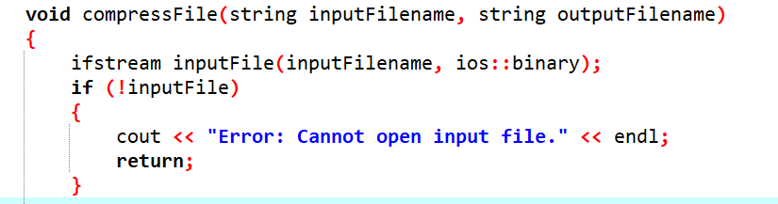

The compressFile function receives inputFileName and outputFileName as inputs. It then performs the necessary error handling to verify that the input file can be opened and that the output file can be created before proceeding with compression.

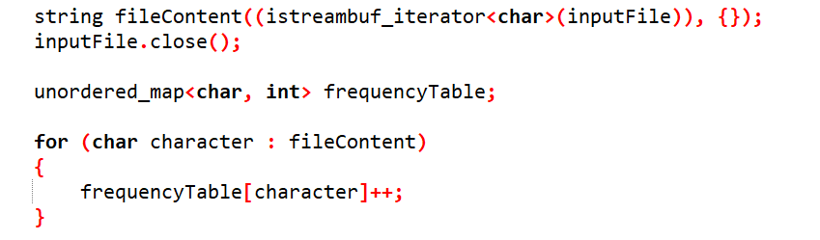

Then we used an unordered_map with char as the key and int as the value. The purpose of this unordered_map is to store the frequency of each character. We created an object named frequencyTable, which counts how many times each character appears in the input, as shown in the dry run with the example sentence below.
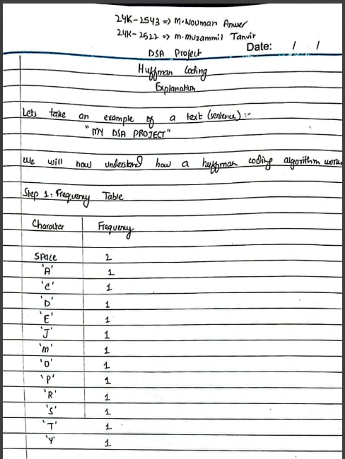

For example:
The space character appears 2 times, which means its frequency is 2.
All other characters appear only once, so their frequency is 1.

Step 02:

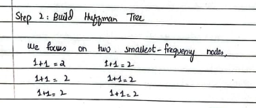

For this, we used priority queue.

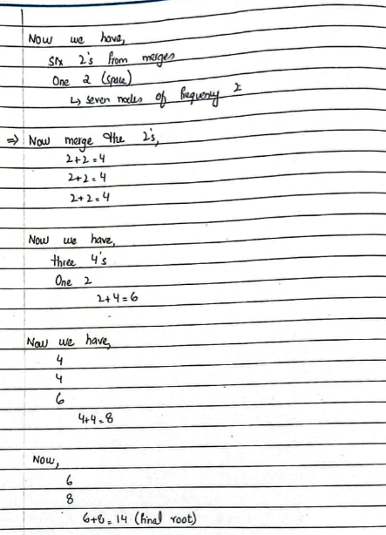

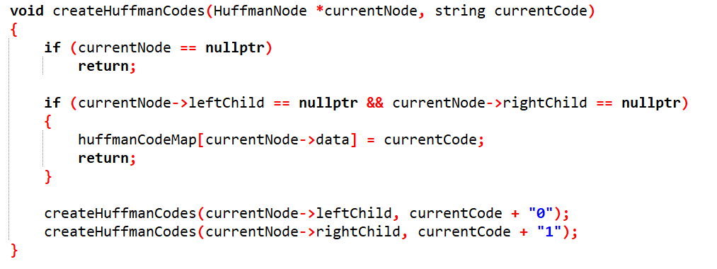

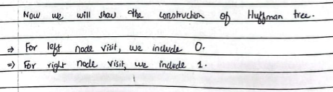

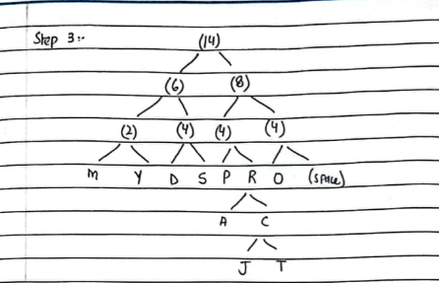

STEP 04:
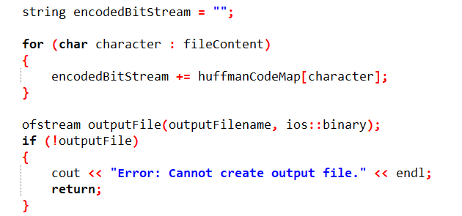

How codes are generated?
Iterate through the Huffman tree for one left move, add 0 and for one right move, add 1. For example, in the given sentence you have to move 4 lefts to get to ‘M’ which means 4 lefts (i.e. code generated 0000).

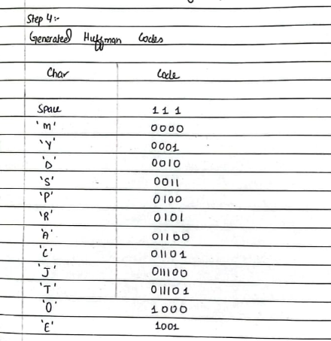

STEP 05:

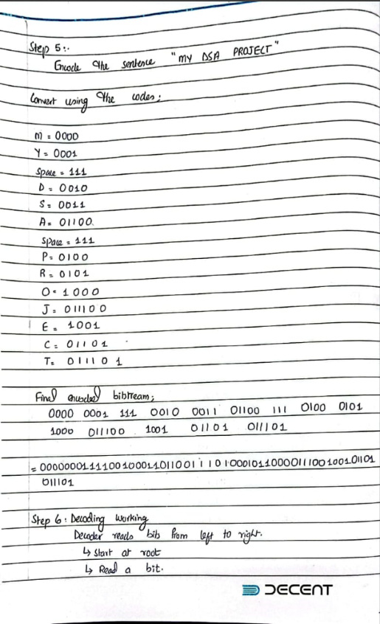
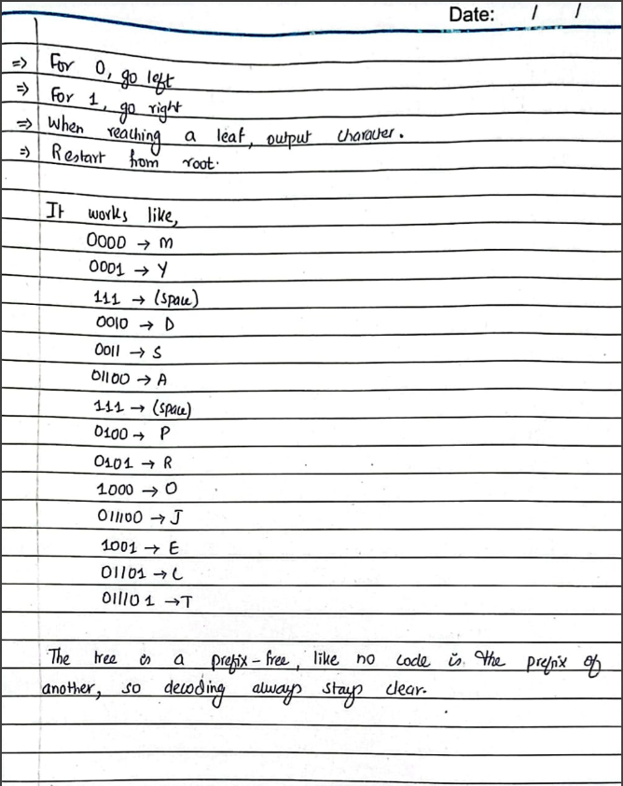

NOTE:
If we can convert data to binary using simple file operations, then why do we use Huffman encoding or other compression algorithms? And do these algorithms store data in files the same way standard binary files are stored?
ANSWER:
Compared to standard binary storage, Huffman encoding stores only the number of bits required for each character instead of always using a fixed 8 bits per character. For example, if the Huffman code for a character is 110 (3 bits), standard storage would still store it using 8 bits, whereas Huffman-based storage uses only those 3 bits, adding padding only at the end to complete the final byte. This is how Huffman encoding saves space—by assigning shorter codes to more frequent characters—resulting in a smaller overall file size compared to standard binary storage.

SUCCESSFUL RUN

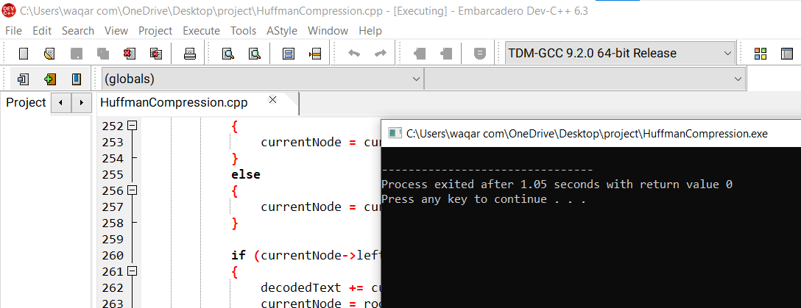

INPUT FILE WITH 5000 WORDS PARA:



RESULT:

Check file size for input and compressed file
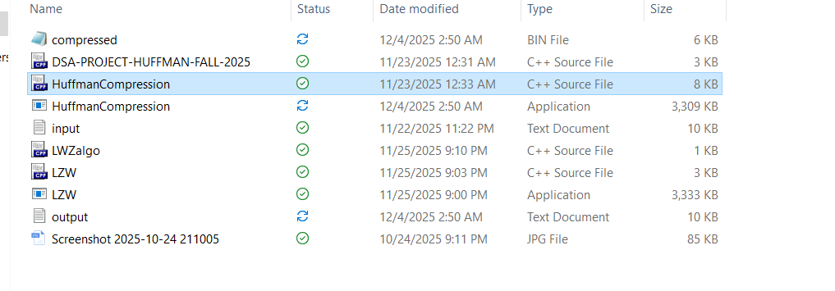

LZW ALGORITHM

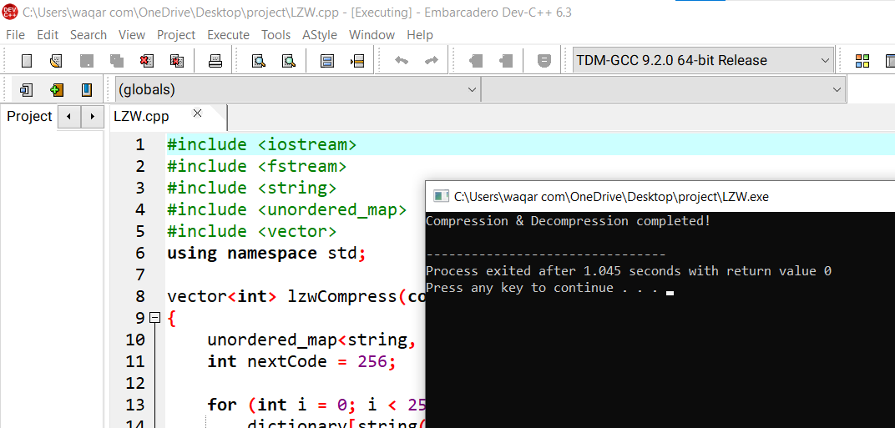

CHECK INPUT AND COMPRESSED FILE SIZE

